
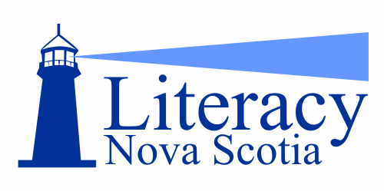

2014 Raise-a-Reader Grants
Organization | Project
Cumberland Adult Network for Upgrading | Host an event of activity stations to provide hands-on learning for children and their caregivers
Dartmouth Learning Network | Workshops for children and parents: math, reading parent-teacher interviews and report cards, and literacy workshops for the NS Bachelor of Education programs on communicating with parents and families
East Hants Community Learning Association | Host a Family Literacy Day event and “Kick off Summer” family picnic.
Eastern Shore Musquodoboit Valley Literacy Network | Host “Get Caught Reading” open house event
Queens Learning Network | Family literacy workshops for parents and children to be held in Queens County Elementary Schools
Read to Me! | 10,000 copies of 50 Best Books for Babies brochure to be included in Read to me! bags

